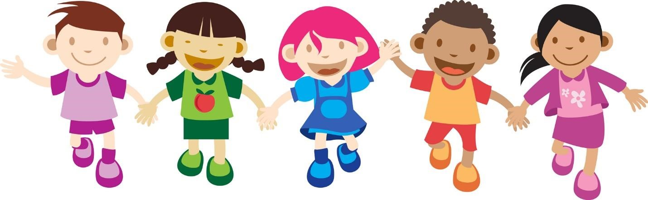
Hablemos : “Let’s speak Spanish”

At: Yinghua International School
Who: All Ages
When: Wednesday from 3:30 to 4:30

Cost: $180 (sessions will begin September 12th and run till November 28th-excluding October 31st and November 23rd) Full Year Option Available
Minimum 3 and maximum 8 kids per group

Class Description

Children naturally learn Spanish through interesting experiences in the same way they learned their first language, without noticing it. They are just having fun, discovering a world of interesting and developmental appropriate activities designed to enhance all areas of development. Children will begin to understand the meaning of isolated words that they relate to what they already know in their native language. Little by little, without noticing it, they will be able to understand a variety of words and will be capable to reproduce as well. But it is not just that. They will learn to combine words into phrases with different linguistic functions. Before they know it, they will be speaking in Spanish and enjoying it.

Instructor-Victoria Cirilo

Immersion Spanish program

- Stories
- Show and Tell
- Dramatic Play
- Art and Crafts
- Games

REGISTRATION FORM:

Student name: _________________________________________________________
Age: _________ School: ________________________________________________
Special needs: ___________________________________________________________
Parents/guardians: _______________________________________________________
Address: ________________________________________________________________
Email address: ___________________________________________________________
Phone # : _____________________ cell:# _______________________
Or register using the contact form at www.yhis.org
Info/questions: victoriacirilo@gmail.com
Please make checks payable to Victoria Cirilo and send with this form to YingHua International School, 25 Laurel Avenue, P.O.
Box 88, Kingston NJ 08528, or turn in to the YingHua School.

