Chinese Story Telling and Puppets
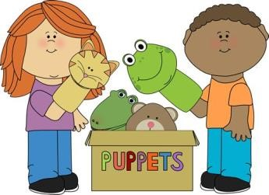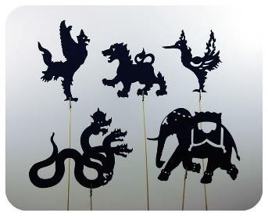
What: Chinese storytelling and use of puppets to tell stories for PS-Kindergarten
Where: YingHua International School, Kingston NJ
When: Tuesday, 4-5 pm, 12 weeks starting September 11th
Cost: $180 for 12 sessions.
Description: Students will have the opportunity to explore the world of story through traditional Chinese storytelling and the use of puppets.

REGISTRATION FORM:

Student name: _________________________________________________________
Age: _________ School: ________________________________________________
Special needs: ___________________________________________________________
Parents/guardians: _______________________________________________________
Address: ________________________________________________________________
Email address: ___________________________________________________________
Phone # : _____________________ cell:# _______________________
Or register using the contact form at www.yhis.org
Info/questions: artisticsophia9@gmail.com
Please make checks payable to CASH and send with this form to YingHua International School, 25 Laurel Avenue, P.O. Box 88, Kingston NJ 08528, or turn in to the YingHua School.

